

Game Pitch Document

Team 14

Team Name

Cyber Knight

09/18/23

**Table of Contents**

Executive Summary 3

High Concept 3

Core Gameplay: Mechanics and Dynamics 3

Core Gameplay Aesthetic 3

Look, Feel, and Sound Aesthetic 3

**Genre, Platform, and ESRB 6**

**Audience and Targeted Customers** **6**

Game Differentiators/Unique Selling Points 7

Current Status, Timeline and Costs 7

# Executive Summary

## High Concept

<A quick overview of the game concept. 3 sentences at most. Include the theme, setting, character, and plot, as appropriate. Must be memorable for the reader and team. The theme is the central idea your design will convey and that drives all or the work you do. Include the setting, such as pirates in space, gangsters under water, steampunk, etc.>

## Core Gameplay: Mechanics and Dynamics

< What does the player do in the game? What is the core gameplay or gameplay loop? How is it compelling?

<Ex: “Navigate through the prison and find the safest way to freedom without being caught. Use secret passages and special abilities to help aid in your escape. The game uses the following core mechanics....From these mechanics, we are designing for the following dynamics to emerge:....” Include the gameplay loop, if needed. What does the player do in the game? What is the core gameplay or gameplay loop? How is it compelling?

## Core Gameplay Aesthetic

< What sort of feelings is the game trying to evoke in the player? Use the gameplay aesthetics as guides but drill down to be make the general category specific for your game, e.g. enactment challenge occurs when players are jumping between platforms, which requires a high degree of eye-hand coordination.>

## Look, Feel, and Sound Aesthetic

<What does the world look like? How does the look convey feeling to the player and support the core aesthetic? Must use visual references or concept art.>

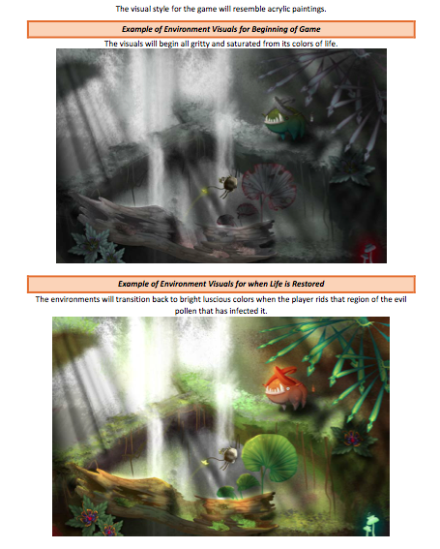

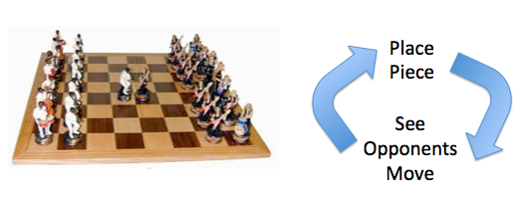

Figure : Medieval War – Brightly Colored Armies

<Use the following to help with the words…

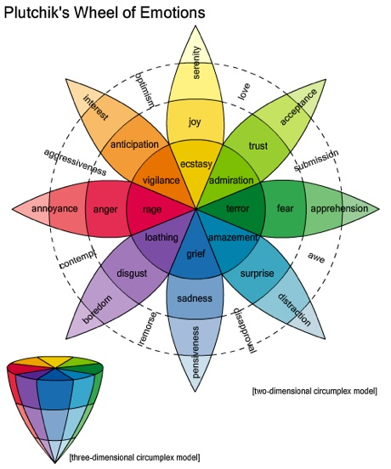



### 

### Genre, Platform, and ESRB

<State the platforms that the game will be deployed and expected ESRB and why (See <https://en.wikipedia.org/wiki/Entertainment_Software_Rating_Board>). Platform is browser based.>

### Audience and Targeted Customers

<Briefly describe the audience and why you think this game will be popular with the audience. Make a player persona (<https://en.wikipedia.org/wiki/Persona_(user_experience>) and <https://medium.com/@fernandocomet/the-player-persona-template-d171e3e0c05d>). Include similar games that the audience may have played previously and enjoyed.>

## Game Differentiators/Unique Selling Points

* <List 1-5 features or elements that makes your game different from those played before.>

## Current Status, Timeline and Costs

<The current status is the game concept phase unless there was some previous work done. Each team and team member will have different costs. Each team member will tell the team how many hours a week, on average, that s/he will commit to. Then, multiply each team member’s commitments by 13 weeks and then add them together for the total amount of person-hours for the project. Then, multiply that by $40.00 (my estimate for the fully burdened cost per person per hour) to determine the total cost of the project. >

<The timeline is the same for the teams. So, just state the date of the final version.>

Signatures verifying agreement: